Module 12 – Location Graph

Exploratory Data Analysis

*In this section, you should perform some data analysis on the data provided to you. Please format your findings in a visually pleasing way and please be sure to include these cuts:*

Model Formulation

*Try to write the formulation of the model into here prior to implementing it in your Excel model. Be explicit with the definition of the decision variables, objective function, and constraints. Hint: Linking constraints aren’t needed since we are using Nonlinear GRG but refer to the associated PowerPoint in your data if you need help.*

Model Optimized for Distance Reduction from DC to Store

*Implement your formulation into Excel and be sure to make it neat. This section should include:*

* *A screenshot of your optimized final model (formatted nicely, of course)*
* *A text explanation of what your model is recommending*
* *Update your graph from the EDA section by adding in your new DC and add indicators of which Stores are serviced by which DC*

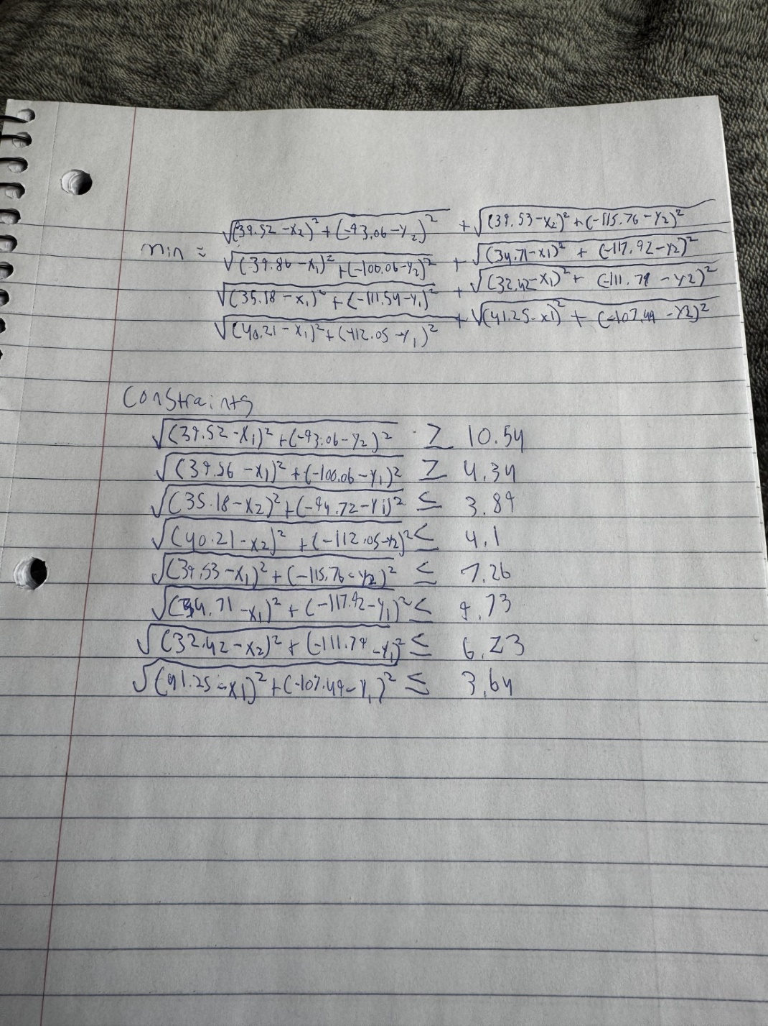

Model with Stipulation

*Please copy the tab of your original model before continuing with the next part to avoid messing up your original solution.*

*You should notice that while distance is minimized between each store and each DC, there is a discrepancy between how much demand is serviced between each DC (i.e. one DC may service a lot more demand than others). Please:*

The model compares the distances with the old and new distribution center. Saying true if closer and false if they are farther away.